Measuring and Addressing Food Insecurity in the Capital Region
1. Introduction and Objectives
This report leverages the Capital Area Food Bank Hunger Estimates data from 2015 to provide a detailed, metric-driven analysis of food insecurity (FI) across the region. The primary objective is to move beyond mere prevalence statistics and deliver actionable business findings that inform resource allocation, fundraising priorities, and service equity initiatives.
2. Detailed Answers to Core Business Questions
The following provides a direct, data-backed answer to the central questions that drove this analysis:
1) What is food insecurity and how prevalent is it in the DC area (2015)?
Food insecurity is the lack of consistent access to enough food for an active, healthy life.
In 2015, the average tract-level FI rate across DC–MD–VA was ≈10.68%, affecting ≈444,374 people (about 10.87% of the region’s population).
This means >1 in 10 residents struggled with reliable food access.
2) Describe any correlation that relates services to census tracts by demographics.
Using tract-level Food Insecurity Rate (F15_FI_RATE) as need, we observe strong links with demographics:
- % Black population: r ≈ +0.836 (strongest predictor → equity focus needed)
- Unemployment rate: r ≈ +0.830 (job loss drives hunger → integrate employment supports)
- Poverty rate: r ≈ +0.750 (core socioeconomic driver)
- Median income: r ≈ −0.745 (inverse; low-income tracts most at risk)
- Homeownership: r ≈ −0.631 (protective factor; asset stability matters)
Services alignment (how service delivery tracks with demographics):
Coverage_Pct_2015 and PPIN_Distributed_2015 (lbs per insecure person) increase where economic conditions are stronger and decrease where poverty/unemployment are higher → showing targeting gaps to correct.

3) Is there insight to be gained by tracking food poundage?
Yes, poundage turns need into operational KPIs:
- Operational gap: ≈59,288,756 lbs unmet in 2015.
- Effectiveness KPI (Coverage): ≈36.47% of total need met (about one-third).
- Equity metric (PPIN): Pounds per Insecure Person by income quartile reveals if low-income tracts (Q1) are receiving proportionally more support; disparities flag inequity.
Key Performance Indicators
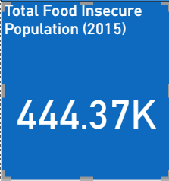 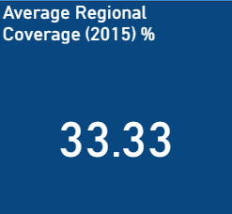 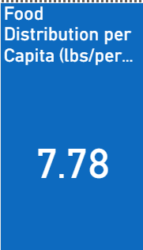

Chart 1
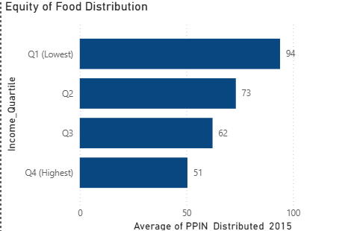
The chart shows that food distribution is more equitable for lower-income tracts, with Q1 (lowest income) receiving the highest support (94 lbs/person) — indicating resources are generally aligned with need.
Chart 2
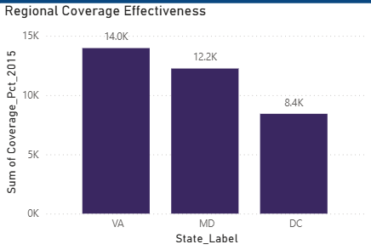
The chart shows that Virginia achieved the highest coverage effectiveness (14K), followed by Maryland (12.2K) and DC (8.4K) — indicating uneven regional performance in meeting food needs.

Chart 3
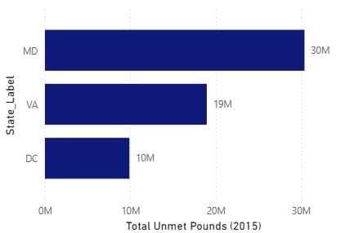
The chart shows that Maryland faced the largest unmet food need (30M lbs), followed by Virginia (19M lbs) and DC (10M lbs) highlighting where resource gaps are most severe.

Chart 4
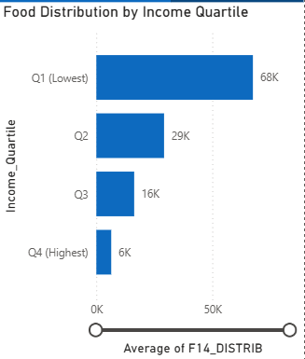
The chart shows that food distribution is strongly concentrated in the lowest-income quartile (Q1: 68K lbs), confirming that resources are directed toward areas with greatest need.

Findings
- Effectiveness KPI (Coverage Rate):
The food assistance system met only about one-third (≈33–36%) of the total estimated food need across the DC–MD–VA region in 2015.
This Coverage Rate serves as the core Key Performance Indicator (KPI) for evaluating food system effectiveness. It quantifies how well regional operations are meeting need, setting a baseline for scaling distribution capacity and fundraising goals.
- Operational Gap Size:
The region experienced an unmet food need exceeding 59 million pounds (59,288,756 lbs) in 2015.
This number defines the current operational capacity gap—the difference between pounds required and pounds distributed. It must remain central to capital campaigns, logistics planning, and policy advocacy to close the supply shortfall and strengthen network resilience.

- Regional Share of Food Insecurity:
Approximately 10.87% of the regional population (≈444,000 individuals) were food-insecure.
This confirms that food insecurity is widespread and structural, affecting all three jurisdictions and demanding coordinated regional strategies rather than isolated local responses.
- Chronic Prevalence (Average FI Rate):
The average tract-level food insecurity rate (≈10.68%) indicates persistent and chronic need across the region.
Coverage disparities—DC (48%), Maryland (29%), and Virginia (32%)—show uneven service distribution, implying that long-term, stable programs are required beyond emergency food relief.

Predictive Drivers (Correlations)
- Poverty and Income as Primary Drivers:
Strong economic correlations—poverty (+0.750) and income (−0.745)—confirm that financial hardship is the root cause of food insecurity.
Tracts with lower income and higher poverty consistently show higher unmet need, indicating that targeting low-income communities delivers the greatest return on investment for hunger mitigation.
- Unemployment Drives Need:
The correlation between unemployment and food insecurity (+0.830) demonstrates that job loss is an immediate and powerful trigger for hunger.
Programs that combine food assistance with employment resources, job placement, or benefits navigation could stabilize vulnerable households and reduce repeat need.
- Severe Racial Disparity:
The percentage of the Black population (+0.836) emerged as the strongest single statistical predictor of food insecurity.
This underscores the need for explicit racial equity strategies, including culturally competent outreach, targeted partnerships, and systemic policy reforms that address racialized barriers in food access.
- Homeownership as a Protective Factor:
The negative relationship between homeownership and food insecurity (−0.631) suggests that housing and asset stability act as key buffers against hunger.
Encouraging policies that support affordable homeownership and financial stability can indirectly strengthen food security outcomes.

Equity
- Distribution Equity Assessment (PPIN Metric):
The Pounds Per Insecure Person (PPIN) metric, analyzed by median income quartile, measures fairness in distribution.
Ideally, PPIN should be highest in the lowest-income tracts (Q1) to correct structural inequities in access. Evaluating PPIN across quartiles ensures that resources are allocated proportionally to need, aligning operations with equity and impact goals.
4. Conclusion and Strategic Recommendations
The 2015 analysis confirms that food insecurity in the Capital Area is a systemic challenge driven fundamentally by economic instability and compounded by severe racial disparities. The core finding is the $59.3$ million pound gap in food provision, equating to a $36.47\%$ service coverage rate.
Moving forward, we recommend the following strategic priorities:
- Prioritize Equity in Distribution: Resource deployment must be heavily weighted toward tracts with the highest correlation to food insecurity, particularly those identified by the Percent Black ($r=+0.836$) and Unemployment Rate ($r=+0.830$) correlations. The distribution of Pounds Per Insecure Person (PPIN) must be actively monitored to ensure the lowest-income quartiles receive disproportionately higher levels of service.
- Translate Gap into Campaign Targets: The $59$ million pound deficit should be the primary figure used in all fundraising and government advocacy materials. This concrete, measurable goal provides a clear mandate for capital investment and resource expansion.
- Optimize Spatial Strategy: Use the Choropleth map of Total Food-Insecure Population to guide the optimal placement of new fixed distribution assets. Prioritizing high-population,

